School: Long Hoa Primary School
Class: 5/______
Name: _______________________________________
GRADE 5
REVIEW
(From 30/3/2020 to 3/4/2020)

1.Look and answer ( Nhìn tranh và trả lời câu hỏi)
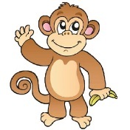 | 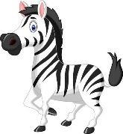
What animal is it ? | What animal is it ? | What animal is it ?
………………………………. | ………………………………. | ……………………………….
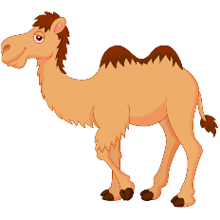 | 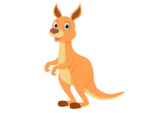 | 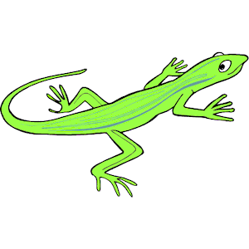
What animal is it ? | What animal is it ? | What animal is it ?
………………………………. | ………………………………. | ……………………………….

2. Look and write. (Nhìn tranh và viết câu trả lời)
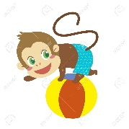 | 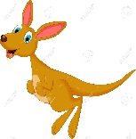 | 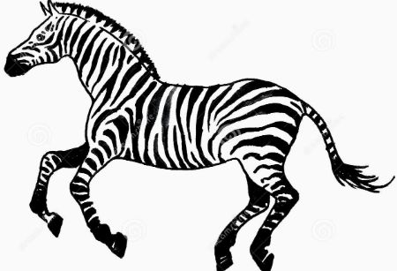
What is the monkey doing ? | What is the kangaroo doing ? | What is the zebra doing ?
…………………………………. | ………………………………… | …………………………………
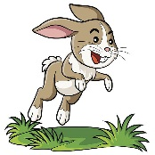 | 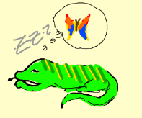
What is the rabbit doing ? | What is the lizard doing ? | What is the fish doing ?
………………………………… | ………………………………… | …………………………………
 | 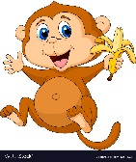 | 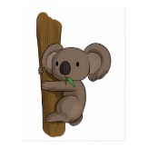
What is the parrot doing ? | What is the monkey doing ? | What is the koala doing ?
………………………………… | ………………………………… | …………………………………
3. Look and write. (Nhìn tranh và viết câu trả lời)
Yes, it is  No , it isn’t. | Yes, they are.  No, they aren’t.

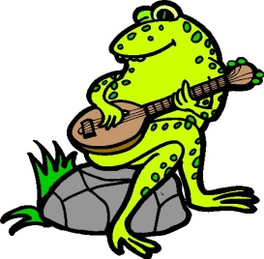 | 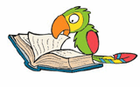
1.Is the frog playing the guitar ? | 2.Is the parrot reading a book ? | 3.Are the birds singing ?
…………………………………… | …………………………………… | …………………………………
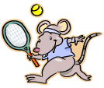 | 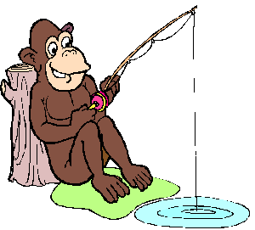 | 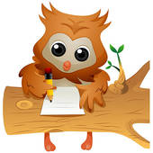
4.Is the rat sleeping ? | 5.Is the monkey fishing ? | 6.Is the owl writing ?
…………………………………… | …………………………………… | …………………………………
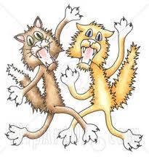 | 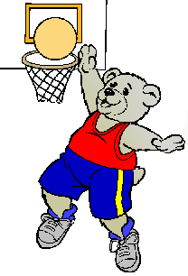 | 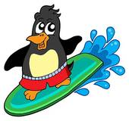
7.Are the cats fighting? | 8.Is the bear playing volleyball ? | 9.Is the penguin surfing ?
…………………………………… | …………………………………… | ………………………………
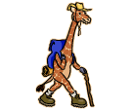

10.Is the giraffe walking ? | 11.Is the dog running ? | 12.Is the squirrel kayaking ?
…………………………………… | …………………………………… | ……………………………………

4. Put the words in the correct order to make sentences. (Sắp xếp các từ thành câu đúng)
flying/The /parrot/is | squirrel/The/is/kayaking. | fishing/The /monkey/is
………………………………… | ………………………………… | …………………………………
 | 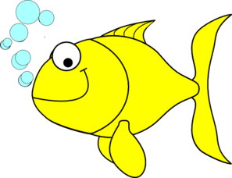
writing/The/owl/is | swimming./The/fish/is | playing/The/guitar./is/frog/the
………………………………… | ………………………………… | …………………………………
lizard/The/is/slepping./ | The/climbing/are/koalas | The /reading/is/ a /book./ parrot
………………………………… | ………………………………… | …………………………………
jumping/The/kangaroo./is | The/flying./birds/are/ | cats/The/are/ fighting
………………………………… | ………………………………… | …………………………………
5.Find the mistakes and correct them. (Tìm lỗi sai và sửa lại trong mỗi câu)
0. The cats is running. The cat is running.
1. The lizard are sleeping.
2. Tony like playing fooball.
3. There is tall trees and pretty flowers.
4. He are kicking the ball.
5. I am run and catching the ball.
6. My friend are playing hike and seek.
7. My mom and my dad is walking in the park now.
8. We is going to the moutain.
9. They are going at school.
10. He is wearing long pant.
11. Lily and Lisa likes zebras.
12. Tony like surfing.
13. The kangaroo are jumping.
14. We sometimes go hiking in Sundays.
15. The balls is flying.
6.Odd one out. (Tìm từ khác loại)
1. a.England b.American c.Japanese d.Vietnamese
2. a.January b.October c.December d.Thursday
3. a.Good morning b.Goodbye c.Good evening d.Good afternoon
4. aplaying b.doing c.morning d.eating
5. a.library b.living room c.classroom d.computer room
6. a.lizard b.rabbit c.camel d.sandwich
7. a.zoo b.school c.book d.park
8. a.play b.violin c.guitar d.piano
9. a.old b.young c.beautiful d.cannot
10. a.nice b.big c.read d.small
The end

The end

