Long Hoa Primary School  Name: …………………………..…………..  Class: 3/…….. | GRADE 3  REVIEW  (05/4 – 09/4/2020)

Exercise 1 Look and write (Nhìn và viết)
 | slide |  | tree | seesaw |  | goal
 | Frisbee |  | ice cream | pool |  | ice cream
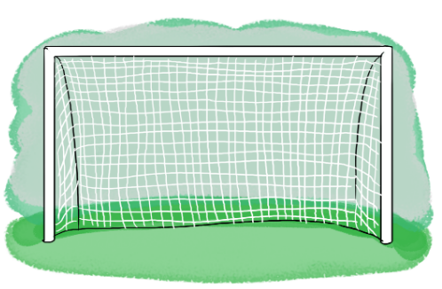 |  | 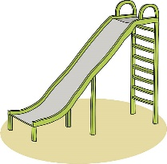 |  |  | 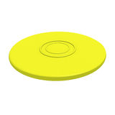
………………….. |  | ………………….. |  |  | ………………….. |  | …………………..
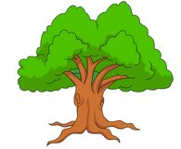 |  | 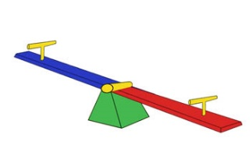 |  |  | 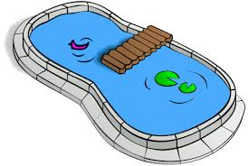 |  | 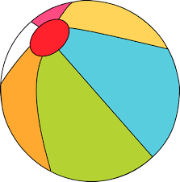
………………….. |  | ………………….. |  |  | ………………….. |  | …………………..

Exercise 2 Look and write (Nhìn và viết câu trả lời đúng)
Yes, it is. | No, it isn’t

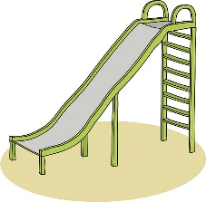
a) Is it a seesaw ? b) Is it a tree ? c) Is it a bag ?
……………………………. ……………………………. …………………………….
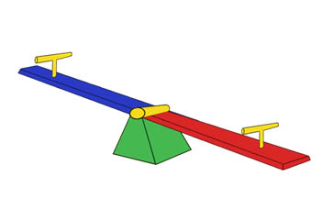
d) Is it a slide ? e) Is it a Frisbee ? f) Is it a goal ?
……………………………. ……………………………. …………………………….
Exercise 3 Look and write (Điền từ chỉ vị trí thích hợp vào chỗ trống)
 | in |  | on | under
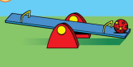 |  | 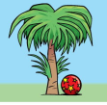 |  |  | 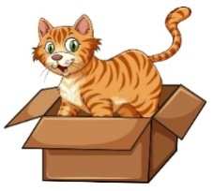
a) The ball is …………the seesaw. |  | b) The ball is …………the tree. |  |  | c) The cat is ………the box.
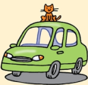 |  | 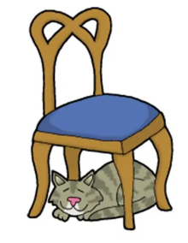
d) The cat is…………the car. |  | a)  e) e) The cat is …………the chair. |  |  | f)The cat is ……the fishbowl.
Exercise 4 Put the words in the correct order (Sắp xếp từ thành câu đúng)
- ball – is – Where – the ?………………………………………………………….
- It’s – the – slide – on……………………………………………………………….
- The – is – ball – the goal – in………………………………………………………
- is – Where – book – the ?…………………………………………………………
- cat – The – under – is – the tree…………………………………………………
- The – bag – on – the desk – is……………………………………………………
Exercise 5 Look and complete the sentence. (Điền từ thích hợp)
- Where ……………..the ball ? The ball is under the table.
- Where is the teddy bear ? It’s ……………..on the bed.
- …………….. the ball on the chair ? Yes , it is.
- Where is the ……………..? The ball is in the pool.
- Is the kite under the slide ? …………….., it is.
- Where …………….. the ball? It’s in the goal.
- Is the book in the bag ? …………….., it isn’t.
- …………….. is the cat ? It’s under the desk.
- Where is the frisbee ? It …………….. in the goal.
- Where is the …………….. ? The doll is in the bag.
Exercise 6 Look at the picture and complete (nhìn tranh và điền từ phù hợp)
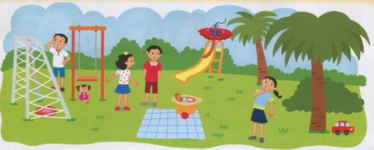

- Where is the frisbee ? It’s ……….……. the goal.
- Where is the kite? It’s on the ………………..
- Where is the doll? It’s ……….…. the swing.
- Where is the ……………….? It’s under the tree.
- There are ……………people in the picture.

Exercise 7 Circle the odd one out (Chọn từ khác loại)
a) kite | b) teddy bear | c) train | d) bag
a) nose | b) robot | c) face | d) leg
a) in | b) under | c) on | d) This
a) kite | b) teddy bear | c) doll | d) bag
a) slide | b) seesaw | c) swing | d) pencil
a) teacher | b) nurse | c) school | d) doctor
a) blue | b) green | c) black | d) tree

Exercise 8 Look and answer. 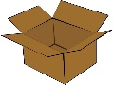 box ; 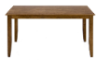 table ; 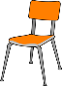 chair ; desk
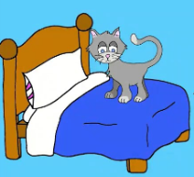 | 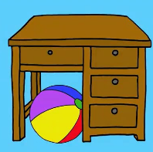 | 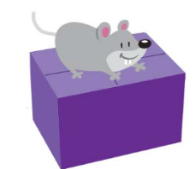
- Where is the cat ? | - Where is the ball ? | - Where is the mouse ?
It’s on the bed. | ………………………………… | …………………………………
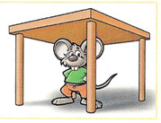 | 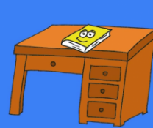 | 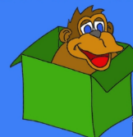
- Where is the mouse? | - Where is the book ? | - Where is the monkey ?
……………………………… | ……………………………… | ………………………………
 |  | 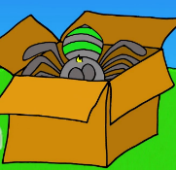
- Where is the cat ? | - Where is the apple ? | - Where is the spider ?
……………………………… | ………………………………… | …………………………………
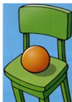 | 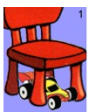
- Where is the ball ? | - Where is the car ? | - Where is the apple ?
………………………………… | ………………………………… | …………………………………

The end

