School: Long Hoa Primary School
Class: 4/______
Name: _______________________________________
GRADE 4
REVIEW
(From 6/4/2020 to 11/4/2020)

1.Write the missing letters
 | 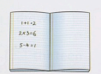 | 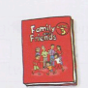
a _ _ | _ _ th | e _ _ lish | _ _
 | 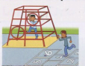
m _ _ _ _ | school y _ _ _ | comput _ _ room | a _ _ r _ _ m
2.Write.
a. What do you have on Monday?  _________________________. (English and Math) | b. What does he have on Tuesday?  ___________________________. (Math and P.E.)
c. ____________ she ______ Math on Thursday?  No, she _______. She ___ Math on Wednesday. | d. _____________ he ________ art on Friday?  Yes, he _________. He _______ art on Friday.
e. What do you we on Monday?  _________________________. (Music and Math) | f. _______________________________________?  We have English and Math on Friday.
g. __________ she _______ English on Tuesday ?  No, she ______. She _______ Math on Tuesday. | f. _______________________________________?  She has Music and Math on Thursday.

3. Write have or has
a. I ____________________ English on Monday.
b. They___________________ Music on Wednesday.
c. Lily and Anna ____________________ Math on Monday and Friday.
d. She ____________________________ PE on Thursday .
e. We _____________________________ English on Tuesday and Friday.
f. Lucas ___________________ Music and Art on Thursday .
g. We ___________________ Art , English and Math on Friday.
h. My brother ____________________ English on Wednesday.
i. My sister __________________________ Math and Art on Monday.
j. Lily and Peter ________________ Art on Monday and Thursday.
k. Anna ______________ English and Music on Friday.
4. Look and circle.
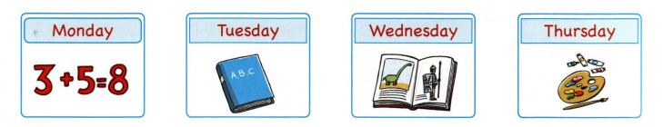
a. They have / don’t have Math on Monday.
b. They have/ don’t have PE on Tuesday.
c. Do /Does they have history on Wednesday ?
d. They have / don’t have English on Thursday.
e. They have / don’t have Art on Monday.
The end

