GRADE 3
REVIEW
(From 30/3/2020 to 3/4/2020)

School: Long Hoa Primary School
Class: 3/______
Name: _______________________________________

Exercise 1 Circle the correct answer.(Chọn từ đúng)
1. 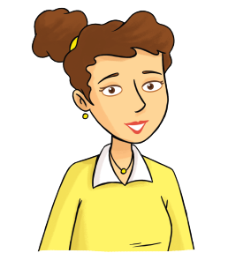 2. 3.
Mom / dad / boy Dad/ grandma / grandpa sister / brother / mom
4. 5. 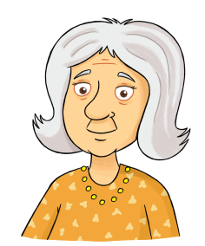 6.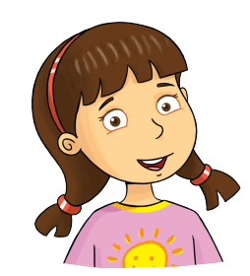
brother / grandpa / dad grandma/ mom / sister brother / sister/ dad
Exercise 2 Look and write (Điền từ He hoặc She vào chỗ trống
He | She
1. 2. 3.
_______ is my mom. ________ is my dad. ________ is my grandma.
4. 5. 6.
______ is my sister. ________ is my grandpa. _________ is my brother.

Exercise 3 Look and write (Đọc câu hỏi và viết câu trả lời)
a) Whose hat is this ?
This is Rosy ’s hat.
b) Whose cat is this ?
……………………………………………..
c) Whose teddy bear is this ?
……………………………………………..
d) Whose bike is this ?
……………………………………………..
e) Whose book is this ?
……………………………………………..
f) Whose kite is this ?
……………………………………………..
g) Whose umbrella is this ?
……………………………………………..

Mom 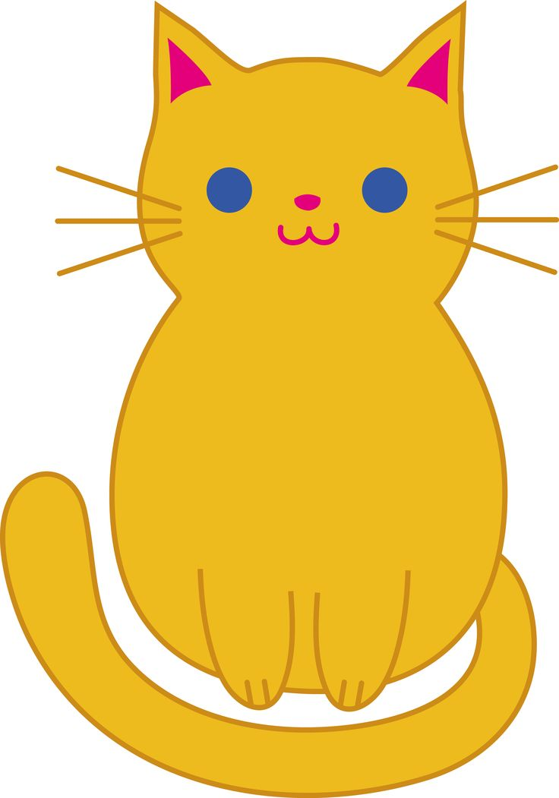
Dad 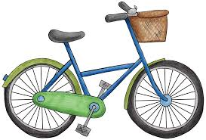
Rosy 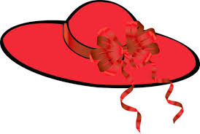
Grandpa
Billy 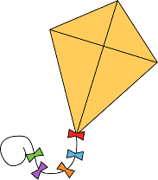
Anna 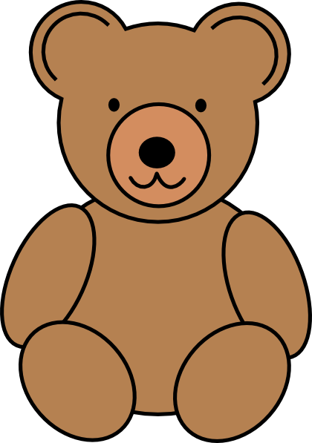
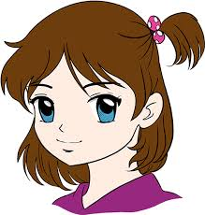Bella

Exercise 4 Order to make sentences. (Sáp xếp từ thành câu đúng)
a) This - is – book - Mum’s This is Mum’s book.
b) is - This - bike - Ben’s ……………………………………………………………………
c) is - This - Dad’s – umbrella ……………………………………………………
d) car - Tony’s - This - is …………………………………………………………
e) bag - Billy’s – It – is ……………………………………………………………
f) Alex’s – pencil – It – is ……………………………………………………………
g) This – Bella’s – is – dog ………………………………………………………………
h) computer – This – Tony’s – is …………………………………………………
i) train – David’s – is – This…………………………………………………………
j) is – This – Sarah’s – teddy bear ………………………………………………………
j) ball – John’s - This – is …………………………………………………………
k) This – dog – is – Peter’s ………………………………………………………………
Exercise 5 Read and match (đọc và chọn câu đúng)
1 - b | - Where is the cat ? | - It’s Anna’s kite.
2- | - What is this | - The cat is under the table.
3- | - Whose bag is this ? | - The book is in the bag.
4- | - Is the ball on the slide ? | - She is a teacher.
5- | - Where is the book ? | - It’s Tony’s bag.
6- | - Whose kite is this ? | - Yes , it is.
7- | - What does he do ? | - My favorite color is green.
8- | - What are these ? | - He’s a police officer.
9- | - What does she do ? | - It’s a train.
10- | - What’s your favorite color ? | - 10) These are my legs.
Exercise 6 Read and circle the correct words. (Đọc và khoanh tròn từ đúng)
  - Whose / Where kite is this ? It’s Tony’s kite.
  - What are these ? This / These are my arms.
  - Is it a pencil ? Yes / No , it is.
  - She is a / an teacher.
  - What / Where is the frisbee ? It’s in the goal.
  - Whoes bag is this ? This is John’s / John bag.
  - What is these / this ? This is my face,
  - What does he do ? She / He is a police officer.
  - Is he a doctor ? Yes, he is / isn’t.
  - These are my ears / ear.
  - Where is the kite ? It is / are on the tree.
Exercise 7 Look and tick () or ()( Nhìn tranh và đánh dấu vào bảng)
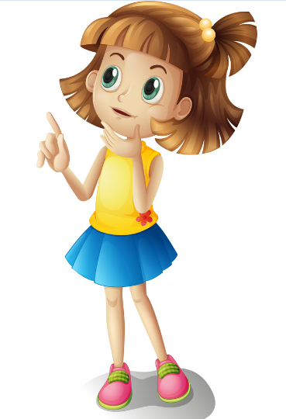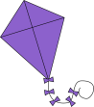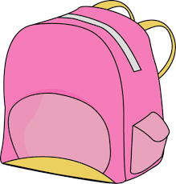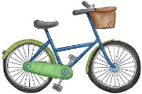  Sarah |  | 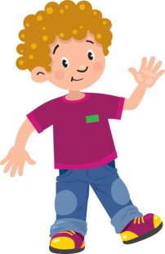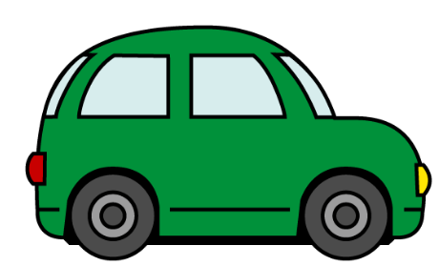  Tony
 | a) This is Tony’s kite.
 | b) This is Sarah’s book.
 | c) This is Tony’s car.
 | d) This is Sarah’s umbrella.
 | e) This is Tony’s bag.
 | f) This is Sarah’ kite.
Exercise 8 Make questions for these answers ( Đặt câu hỏi từ câu trả lời)
a) This is Daisy’s bag. Whose bag is this ?
b) The Frisbee is in the goal. …………………………………………………………
c) This is Sarah’s teddy bear. ……………………………………………………………
d) The book is in the bag. …………………………………………………………
The end

