School: Long Hoa Primary School
Class: 4/______
Name: _______________________________________
GRADE 4
REVIEW
(From 30/3/2020 to 3/4/2020)

1.Look and write
get up have breakfast go to school go home have dinner go to bed
I _________ at five o’clock. | I _________ at seven o’clock.
 | 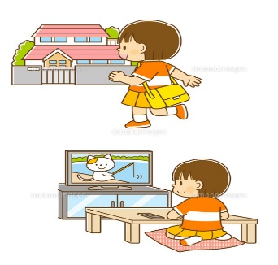
I _________ at six o’clock. | I _________ at four o’clock.
 | 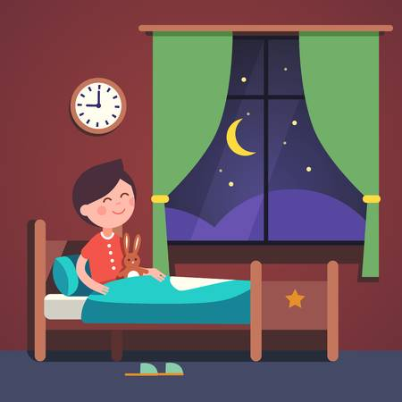
We _________ at seven o’clock. | I _________ at nine o’clock.
2.Circle
a. I don’t / doesn’t get up at six o’clock.
b. He don’t /doesn’t swim in the evening.
c. We don’t /doesn’t go to school in the summer.
d. The shop don’t /doesn’t open at six o’clock in the morning.
e. My brother don’t / doesn’t play in the park every morning.
f. Lucy doesn’t /don’t watch TV in the afternoon.
g. She don’t /doesn’t go to school at seven o’clock.
h. I don’t /doesn’t have dinner at seven o’clock.
i. Lisa doesn’t /don’t have breakfast at six o’clock.
3. Choose and write.
play get up ride eat write go

1. I get up at seven o’clock . I don’t get up at eight o’clock.
2. We ____________to school everyday . We _________ to the zoo.
3.My brother ____________ football. He __________volleyball.
4.My dad _________ pizza in the evening. He __________it for breakfast.
5. We _____________our bikes in the park . We____________ our bikes in the house.
6. I ______________ postcards on holiday. I _____________ postcards at home .
The end

